
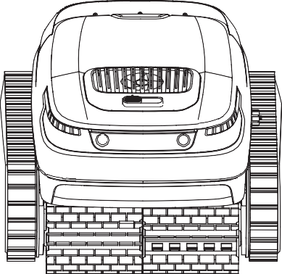
User Manual

Please read this manual carefully before using the product and store the manual properly.


Contents
Contents

EN | English | . P01-P08 | 1.WARNINGS P01-P01
DE | Deutsch | . P09-P13 | 2.Packing List P02-P02
FR | Français | . P14-P19 | 3.Product Overview P02-P02
IT | Italiano | . P20-P25 | 4.Instructions for Use P02-P04
ES | Español | . P26-P31 | 5.Daily Maintenance P04-P04
 |  |  | 6.Off-season Storage P04-P04
- Parts Replacement P04-P05

- FAQs ............................................................................................P05-P06
 |  |  | 9.Compliance Statement P06-P07

WARNINGS
Thank you for purchasing Air Robo-Charge Robotic Pool Cleaner.
EN Please read this manual carefully before using the product for the first time and keep this manual for future reference.

- This product is intended for domestic use only and not for commercial or industrial purposes.
- This product has undergone rigorous testing before leaving the factory, including underwater testing. Therefore, there may be a small amount of water droplets or dirt remaining inside, which will not affect the operation of the product. Please feel free to use it normally.
- Do not operate the device when people or animals are in the pool.
- Please fully charge the robot before using it for the first time.
- Use only the adapter provided with the product for charging. Never use a third-party adapter. Do not use extension cables under any circumstances. Keep the product away from combustible materials when charging.
- Do not use a damaged power adapter to charge the product. A damaged power cord must be replaced by the manufacturer, a service agent, or personnel with similar qualifications. Never try to repair a damaged power cord by yourself. If repair is required, contact us.
- Make sure that the charging port is dry before connecting the product to the power supply.
- Please charge the product in a safe place away from water.
- Ensure that the power outlet is protected by a ground fault interrupter (GFI) or a ground leakage circuit breaker.
- Do not charge or use the robot when any abnormality is detected. Please contact customer service.
- This robot is not intended for use by people with reduced physical, sensory, or mental capabilities or lack of experience and knowledge (including children) unless they have been given supervision or instruction for using the robot by a person responsible for their safety.
- Children should be supervised to ensure that they do not play with the robot.
- Cleaning and maintenance must not be performed by children without supervision.
- All packaging materials should be disposed of properly and kept away from children and pets.

- This product contains a non-replaceable battery. Do not disassemble the battery. When the battery life ends, the robot should be disposed of properly.
- Do not attempt to repair or modify any part of your product. All repairs must be done by qualified personnel only. No user-serviceable parts are included. If repair is required, contact us.
- This product must be serviced by a qualified professional with suﬃcient experience in the installation and maintenance of swimming pool equipment so that all instructions in the complete installation and operation manual can be accurately followed. Be sure to explicitly follow all safety instructions in the complete manual to prevent the risk of injury. No user-serviceable parts are included. Please contact us when you need repair services.
- Before cleaning or maintaining the robot, be sure to unplug the power plug from the power outlet.
- Do not pierce the robot casing with nails or other sharp objects. Do not hammer, impact, or throw the robot.
- Do not expose the product or battery to excessive temperatures.
- Be sure to remove the battery from the robot before recycling or disposing of the robot. When removing the battery, always disconnect the robot from the power supply.
- Please dispose or recycle used batteries in accordance with local administrative regulations. Consult a professional recycling agency if necessary.
- The oil sealing around the motor contains grease, which may cause a small amount of water pollution if the motor is damaged. If you believe there is a leak, stop using the product immediately.
- The charging position of the product should be at least 3 meters away from the edge of the pool
- Only use the robot under the following water conditions:
Chlorine | Max 4 ppm
PH | 7.0-7.4
Temperature | 5-35°C（41-95℉）
Sodium chloride | Max 5000 ppm
Before charging, read the instructions. Maximum operating depth：2.5m.

- Packing List
Applicable pool size | swimming pool of 1,076 square feet (100 square meters)
Pool depth | 0.5-2.5 m (1.64-8.2 ft)
Robot dimensions | 475 × 395 × 250 mm/18.7 × 15.6 × 9.8 inches
Robot weight | 9 kg/19.8 lbs
Charger input | 100-240 V~50/60 Hz
Charger output | 29.2 V 3 A (US: 29.4 V 3 A)
Robot input | 29.2 V 3 A (US: 29.4 V 3 A)
Lithium battery capacity Max | 5,200 mAh
Battery life | ≥ 2 hours
Charging time | 2.5 hours
Filter density | 180 μm
Moving speed | 10-15 m/min (32.8-49.2 ft/min)
Waterproof rating | IP68
Storage temperature | -20°C to +45°C

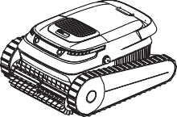
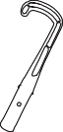
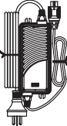
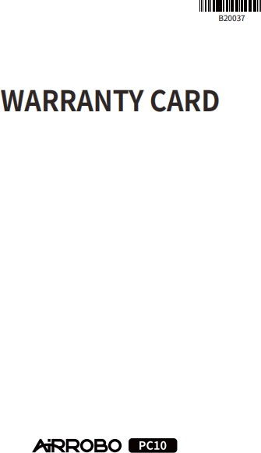
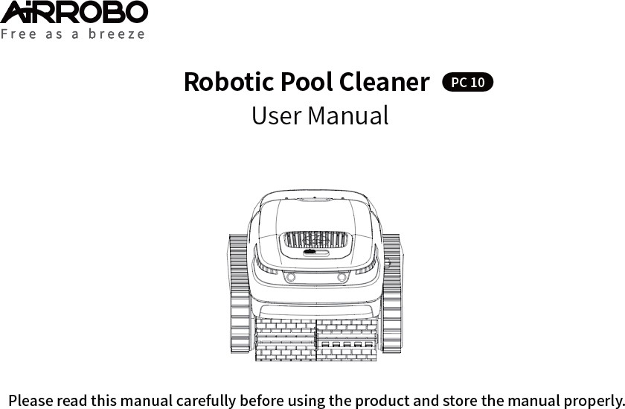
EN

Robotic Pool Cleaner
(With built-in filter) × 1 Power adapter × 1 Hook × 1 Warranty card × 1
Maintenance kit × 1 Including:
Combined machine screw 1 × 2pcs. Combined machine screw 2 × 2pcs. Self-tapping screw 1 × 4pcs.
Self-tapping screw 2 × 4pcs. Flip buckle hand piece × 1pcs.
User manual × 1 Circlip × 4pcs. Washer × 4pcs.
Rubber strip × 1pcs.

- Product Overview
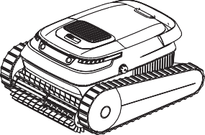
Switch/Cleaning mode selection

Cleaning roller brush

Water outlet

Charging port (with protective cover)

Instructions for Use

Charging
    - Please fully charge the robot before using it for the first time.
    - Remove the robot from the pool and turn it off.
    - Make sure that the charging port is dry.

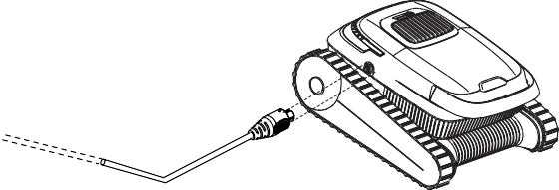
Status indicator light strip

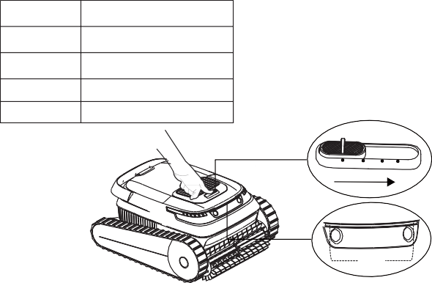
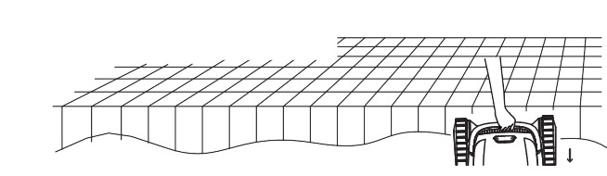
  - Power and status indicators
LED Color Status
Green Suﬃcient battery
Blue Insuﬃcient battery
Orange Very low battery
Red Fault
OFF
AUTO FLOOR WALL
LED
② Slowly put the robot into the water. Then, the robot will release the air in the body and sink to the bottom of the pool.

EN

Cleaning Mode
LOGO
Cleaning Mode |  | Cleaning Area
Intelligent cleaning | A UTO | Clean the floor/wall/waterline
Floor cleaning | FLOOR | Clean only the floor
Wall cleaning | WALL | Clean the wall and waterline

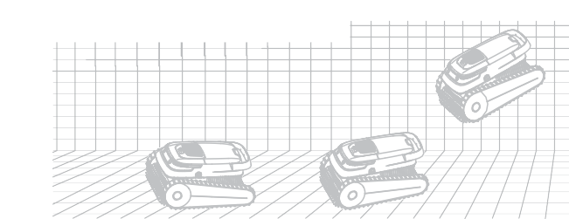
Taking out of the swimming pool
③ The robot will start working within 10 seconds after reaching the bottom of the pool.
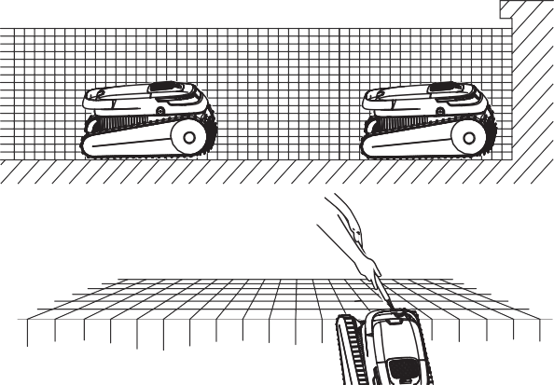
① The robot will automatically stop at the bottom edge of the swimming pool after the cleaning task is completed or when the battery power is low.

Placing the robot into the water
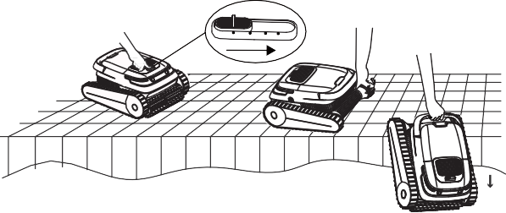
① Select the desired cleaning mode, and place the robot in the water as soon as possible.

OFF AUTO FLOOR WALL

② Use a hook to lift it out of the pool.

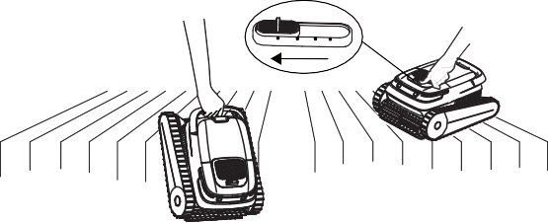
③ Remove the robot from the pool and turn it off.
OFF AUTO FLOOR WALL

Cleaning the filter basket
We strongly advised cleaning the filter basket after each cleaning task.
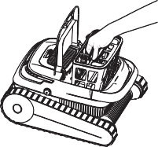
① Open the robot compartment cover. ② Remove the filter basket.
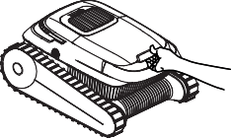

After daily use
    - Clean the robot and filter basket after each cleaning.
    - Keep away from direct sunlight.
EN
    - Make sure that the charging port is dry before charging.

Every 3-4 months or after a deep cleaning cycle (when the pool is dirty)
    - Check to make sure that there is no debris in the roller brushes, tracks, and gears.

Every 12 months or when the robot is found to be working/rotating slowly
    - Check the tracks and roller brushes for wear.If they are worn, replace them.

Off-season Storage
If the robot will not be used for a long time, perform the following storage steps:
- Thoroughly clean and dry the filter basket, roller brushes, and tracks.
- Ensure that there is no residual water in the cleaner.
- Fully charge the robot before storage. Place it in a well-ventilated, cool place with a temperature between 5°C and 45°C (41°F and 113°F) and a humidity below 80% RH. Avoid direct sunlight, rain, or frost.
- The battery should be charged at least every 3 months to prevent over-discharge.
- Do not leave the robot within the reach of children or people with reduced physical, sensory, or mental capabilities or lack of experience and knowledge unless they

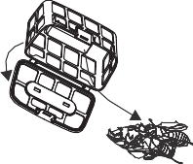
③ Open the filter basket cover and remove the debris.
④ Rinse the filter basket.
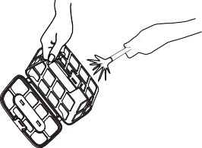
have been given supervision or instruction.

Parts Replacement

Roller brush replacement
① On the back of the roller brush belt, peel off the silicone buckles fixing the mounting grooves.
② Remove all the silicone buckles, replace the roller brush belt with a new one, align the silicone buckles with the mounting grooves, and press the buckles to fix them
in the grooves.

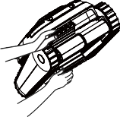
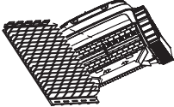
Note: Please clean the filter basket in time. A clogged filter can affect the overall cleaning performance of the robot, making it diﬃcult to generate suction or trap dirt and debris in the filter basket. If cleaning has no effect, the filter basket needs to be replaced.

Daily Maintenance
For optimal product performance, follow these instructions to maintain the robot.

Track replacement
①Remove the side panels: Remove the two screw covers. Using a Phillips screwdriver to unscrew the two screws holding the side panels and track panels in place. Remove the side panels and track panels and set them aside.
EN
② Clean: Clean the inside of the side panels and dry them with a paper towel or cloth.
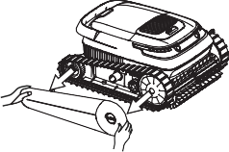
③ Replace: Replace the tracks as required.
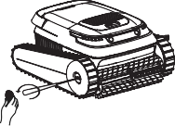
Remove the screw cover and unscrew the screws. Remove the side panels

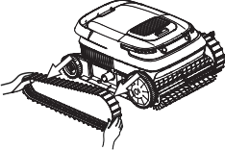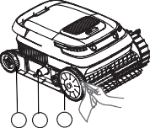

3 2 1

8.FAQs
Remove the tracks. Clean the inside of the side panels

If an issue persists after the suggested solutions are implemented, contact customer support for assistance.
The robot does not charge. | - The power adapter does not work. | - Check whether the charging LED is displayed when the adapter is connected to the robot. If not, replace the charger.
The robot does not charge. | - Water entered the charging port. | - Dry the charging port and try  charging again.
The robot does not work or the indicator does not turn on. | - The robot does not have enough battery. | - Use the robot after fully charging it.
The robot does not work or the indicator does not turn on. | - The robot switch fails. | - Try turning the robot off and on again.
The robot does not climb walls. | - The battery is low. | - Use the robot after fully charging it.
The robot does not climb walls. | - Check whether the robot works in floor cleaning mode and  cleans only the floor. | - Switch to wall cleaning mode.
The robot does not climb walls. | - The filter basket is clogged. | - Clean the filter basket.
The robot does not climb walls. | - There is algae on the wall and the pH value is not right. | - Check the levels of chemicals in the water. Poor water quality can allow algae to grow, making walls slippery. In this case, adjust the water quality and scrub the walls.
The robot does not climb walls. | - The tracks and/or roller brushes are worn. | - Replace the tracks and/or roller brushes.
The robot moves in circles. | - The filter basket is clogged. | - Clean the filter basket.
The robot moves in circles. | - Debris gets stuck on the tracks or roller brushes. | - Remove debris from tracks or roller brushes. See page 4 for parts replacement instructions.
The robot stops underwater and the fault indicator indicates that the motor or water pump is blocked. | - Debris gets stuck on the tracks or roller brushes. | - If the motor is stuck, check whether the left/right track can be manually rotated. If not, check for obstructions on the  track.
 | - Debris blocks the water pump motor impeller. | - If the water pump motor is stuck, check for obstacles on the impellers.

Issue | Possible Causes | Solutions
The robot does not charge. | - The power outlet has no power. | - Check whether the power outlet is working.
The robot does not charge. | - The power cord is not properly connected to the power outlet. | - Check the connection between the power cord and the power outlet.
The robot does not charge. | - The connection between the power adapter and robot is loose. | - Check the connection between the robot and the adapter.

There are water droplets and dirt in the newly purchased robot. | - Every robot has undergone rigorous testing before leaving the factory, including underwater testing. Therefore, there may be a small amount of water droplets or dirt remaining inside. Please feel free to use the robot normally. motor impeller. | - This does not affect the operation of the robot.

Declaration of Conformity
  - FCC compliance statement This device complies with part 15 of the FCC Rules. Operation is subject to the following two conditions:
- This device may not cause harmful interference, and
- this device must accept any interference received, including interference that may cause undesired operation. Changes or modifications not expressly approved by the party responsible for compliance could void the user's authority to operate the equipment.

Note: This equipment has been tested and found to comply with the limits for a Class B digital device, pursuant to part 15 of the FCC Rules. These limits are designed to provide reasonable protection against harmful interference in a residential installation. This equipment generates, uses and can radiate radio frequency energy and, if not installed and used in accordance with the instructions, may cause harmful interference to radio communications. However, there is no guarantee that interference will not occur in a particular installation. If this equipment does cause harmful interference to radio or television reception, which can be determined by turning the equipment off and on, the user is encouraged to try to correct the interference by one or more of the following measures:
  - Reorient or relocate the receiving antenna.
  - Increase the separation between the equipment and receiver.
  - Connect the equipment into an outlet on a circuit different from that to which the receiver is connected.
  - Consult Robo-Tek for assistance service@robo-tek.com.au

WEEE Disposal and Recycling Information
All products bearing this symbol are waste electrical and electronic equipment EN
(WEEE as in directive 2012/19/EU) which should not be mixed with unsorted
household waste. Instead, you should protect human health and the environment by handing over your waste equipment to a designated collection point for the recycling of waste electrical and electronic equipment, appointed by the government or local authorities. Correct disposal and recycling will help prevent potential negative consequences to the environment and human health. Please contact the installer or local authorities for more information about the location as well as terms and conditions of such collection points.

ISEDC TO CANADIAN USERS
CAN ICES-3(B)/NMB-3(B)
This device contains licence-exempt transmitter(s)/receiver(s) that comply with Innovation, Science and Economic Development Canada’s licence-exempt RSS(s). Operation is subject to the following two conditions:
- This device may not cause interference.
- This device must accept any interference, including interference that may cause undesired operation of the device. This Class B digital apparatus complies with Canadian ICES‐003. This device complies with RSS‐247 of ISEDC. Operation is subject to the condition that this device does not cause harmful interference.

L'émetteur/récepteur exempt de licence contenu dans le présent appareil est conforme aux CNR d’Innovation, Sciences et Développement économique Canada applicables aux appareils radio exempts de licence. L'exploitation est autorisée aux deux conditions suivantes :
- L'appareil ne doit pas produire de brouillage;
- L'appareil doit accepter tout brouillage radioélectrique subi, même si le brouillage est susceptible d'en compromettre le fonctionnement. Cet appareil numérique de la Classe B conforme à la norme NMB‐003 du Canada. Cet appareil est conforme à la norme RSS ‐ 247 d'ISEDC. Le fonctionnement est soumis à la condition que cet appareil ne provoque pas d'interférences nuisibles.

  - EU Declaration of Conformity Product description: Robotic Pool Cleaner Type designation(s):PC10 Trademark: AIRROBO
EN
Hereby we, Name of manufacturer: Best Epoch Technology Co., Ltd.
Address:2201, Block C1, Nanshan I Park, No. 1001 Xueyuan Road, Nanshan District, Shenzhen City,P.R.CHINA declare under our sole responsibility that the product described above is in conformity with the relevant Union harmonization legislations:European Directive(Low Voltage Directive 2014/35/EU,Electromagnetic Compatibility Directive 2014/30/EU)

The following harmonized standards and/or other relevant standards have been applied, which included for Article 3.1b EMC, Article 3.1a Electrical Safety rquirements: EN IEC 55014-1:2021
EN IEC 55014-2:2021 EN IEC 61000-3-2:2019+A1:2021
EN 61000-3-3:2013+A1:2019+A2：2021 EN IEC 60335-2-41:2021+A11:2021
EN 60335-1:2012+A11:2014+A13:2017+A1:2019+A14:2019+A2:2019+A15:2021 EN 62233:2008

The performed the conformity assessment according to the European Directive, The laboratory issuing the report is Bay Area Compliance Laboratories Corp.(Dongguan).
This declaration of conformity is issued under the sole responsibility of the manufacturer. Signed for and on behalf of: Best Epoch Technology Co., Ltd.
Place: Shenzhen,China.
Name: Lucia Liu Position: Certification Engineer
Signature: Date: March 25,2024

Contents
DE

WARNHINWEISE
Vielen Dank, dass Sie sich für den Airrobo Roboter-Poolreiniger entschieden haben.

      - WARNHINWEISE P08-P09

      - Verpackungsinhalt........................................................................P09-P09

      - Produktübersicht .......................................................................... P09-P10

      - Gebrauchsanweisung....................................................................P10-P11

      - Tägliche Wartung..........................................................................P12-P12

      - Längere Lagerung außerhalb der Saison.........................................P12-P12 7.Austausch von Ersatzteilen............................................................ P12-P12
8.Häufig gestellte Fragen (FAQs)......................................................... P13-P13
Bitte lesen Sie dieses Handbuch vor der ersten Benutzung des Geräts sorgfältig durch und bewahren Sie es zum späteren Nachschlagen auf. DE
  - Dieses Gerät ist nur für den Hausgebrauch und nicht für gewerbliche oder industrielle Zwecke bestimmt.
  - Dieses Gerät wurde vor dem Verlassen des Werks strengen Tests unterzogen, einschließlich Unterwassertests. Aus diesem Grund kann eine kleine Menge an Wassertropfen oder Schmutz im Inneren zurückbleiben, wodurch aber die Funktion des Geräts nicht beeinträchtigt wird. Das Gerät kann ganz normal verwendet werden.
  - Betreiben Sie das Gerät nicht, wenn sich Menschen oder Tiere im Schwimmbecken befinden.
  - Bitte den Roboter vor der ersten Verwendung vollständig aufladen.
  - Zum Aufladen nur den mit dem Gerät gelieferten Netzadapter verwenden. Niemals einen Netzadapter eines Drittanbieters verwenden. Auf keinen Fall Verlängerungskabel verwenden. Das Gerät beim Aufladen von brennbaren Materialien fernhalten.
  - Zum Aufladen des Geräts nur unbeschädigte Netzadapter verwenden. Ein beschädigtes Netzkabel muss durch den Hersteller, einen Kundendienst oder ähnlich qualifizierte Fachkräfte ersetzt werden. Niemals versuchen, ein beschädigtes Netzkabel selbst zu reparieren. Setzen Sie sich mit uns in Verbindung, wenn eine Reparatur erforderlich ist.
  - Überprüfen Sie, ob der Ladeanschluss trocken ist, bevor Sie das Gerät an das Stromnetz anschließen.
  - Bitte laden Sie das Gerät an einem sicheren Ort auf, der sich nicht in der Nähe von Wasser befindet.
  - Überprüfen Sie, ob die Steckdose durch einen Fehlerstromschutzschalter (FI) geschützt ist.
  - Laden Sie den Roboter nicht auf und verwenden Sie ihn nicht, wenn Sie eine Störung feststellen. Bitte wenden Sie sich in diesem Fall an den Kundendienst.
  - Dieser Roboter ist nicht dafür bestimmt, von Personen mit eingeschränkten physischen, sensorischen oder geistigen Fähigkeiten oder mangelnder Erfahrung und mangelndem Wissen (einschließlich Kindern) benutzt zu werden, es sei denn, sie werden von einer Person, die für ihre Sicherheit verantwortlich ist, beaufsichtigt oder erhielten von ihr Anweisungen zur Benutzung des Roboters.
  - Kinder müssen beaufsichtigt werden, um sicherzustellen, dass sie nicht mit dem Roboter spielen.
  - Die Reinigung und Wartung darf nicht von Kindern ohne Aufsicht durchgeführt werden.

    - Alle Verpackungsmaterialien sind ordnungsgemäß zu entsorgen und von Kindern und Haustieren fernzuhalten.
    - Dieses Gerät enthält einen nicht austauschbaren Akku. Der Akku darf nicht zerlegt
DE werden. Wenn die Nutzungsdauer der Akku abgelaufen ist, muss der Roboter ordnungsgemäß entsorgt werden.
    - Versuchen Sie nicht, Teile des Geräts zu reparieren oder zu verändern. Alle Reparaturen müssen von qualifizierten Fachkräften durchgeführt werden. Im Gerät sind keine vom Benutzer zu wartenden Teile enthalten. Setzen Sie sich mit uns in Verbindung, wenn eine Reparatur erforderlich ist.
    - Dieses Gerät muss von einer qualifizierten Fachkraft mit ausreichender Erfahrung in der Installation und Wartung von Schwimmbadanlagen gewartet werden, damit alle Anweisungen in der vollständigen Installations- und Betriebsanleitung genau befolgt

2.Verpackungsinhalt

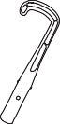
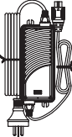
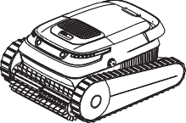
Roboter-Poolreiniger (Mit eingebautem Filter) × 1 Netzadapter × 1

Haken × 1
Wartungskit × 1 Inklusive:

Wartungskit

Garantiekarte × 1

werden. Beachten Sie unbedingt alle Sicherheitshinweise in der vollständigen Anleitung, um das Risiko von Verletzungen zu vermeiden. Im Gerät sind keine vom Benutzer zu wartenden Teile enthalten. Bitte wenden Sie sich an uns, wenn Reparaturen erforderlich sind.
    - Vor der Reinigung oder Wartung des Roboters unbedingt den Netzstecker aus der Steckdose ziehen.
    - Das Robotergehäuse nicht mit Nägeln oder anderen scharfen oder spitzen Gegenständen durchstoßen. Nicht auf den Roboter hämmern, schlagen und den Roboter nicht werfen.
    - Das Gerät und den Akku nicht zu hohen Temperaturen aussetzen.
    - Unbedingt den Akku aus dem Roboter ausbauen, bevor er recycelt oder entsorgt wird. Den Roboter zum Ausbauen des Akkus immer von der Stromversorgung trennen.
    - Bitte verbrauchte Akkus in Übereinstimmung mit den örtlichen Verwaltungsvorschriften entsorgen oder recyceln. Wenden Sie sich bei Bedarf an ein professionelles Recyclingunternehmen.
    - Die Öldichtung um den Motor herum enthält Fett, das bei einer Beschädigung des Motors eine geringe Wasserverschmutzung verursachen kann. Wenn Sie der Meinung sind, dass ein Leck vorliegt, stellen Sie die Verwendung des Geräts sofort ein.
    - Den Roboter nur unter den folgenden Wasserbedingungen verwenden:

Benutzerhandbuch × 1

3.Produktübersicht
Schalter/Auswahl von Reinigungsmodus
Kombi-Maschinenschraube 1 × 2 Stk. Kombi-Maschinenschraube 2 × 2 Stk. Selbstschneidende Schraube 1 × 4 Stk. Klappgriff × 1 Stk. Bzw. 2 × 4 Stk.
Unterlegscheibe × 4 Stk. Sicherungsring × 4 Stk. Gummiband × 1 Stk.

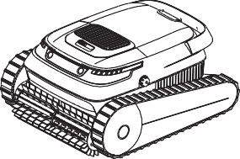
Wasserauslass

Vor dem Aufladen
Chlor | Maximal 4 ppm
PH | 7.0-7.4
Temperatur | 5‒35 °C (41-95°F)
Natriumchlorid | Maximal 5.000 ppm

Reinigungswalzenbürste
Ladeanschluss (mit Schutzabdeckung)

Bitte lesen Sie die Anleitung.

Maximale Hausaufgabentiefe：2.5m.
Statusanzeige-Lichtleiste

4.Gebrauchsanweisung

Aufladen
    - Bitte den Roboter vor der ersten Verwendung vollständig aufladen.
    - Entfernen Sie den Roboter aus dem Becken und schalten Sie ihn aus.
    - Überprüfen Sie, ob der Ladeanschluss trocken ist.
  - Betriebs- und Statusanzeigen

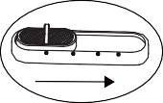
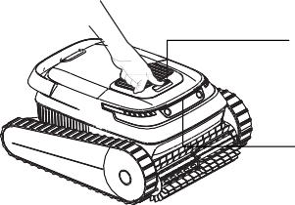
DE
OFF AUTO FLOOR WALL
LED
Maximale Poolgröße | 100-Quadratmeter-Pool
Pooltiefe | 0,5‒2,5 m
Roboterabmessungen | 475 × 395 × 250 mm
Robotergewicht | 9 kg
Ladegeräte-Eingang | 100-240 V~50/60 Hz
Ladegeräte-Ausgang | 29.2 V 3 A (US: 29.4 V 3 A)
Host-Eingabe | 29.2 V 3 A (US: 29.4 V 3 A)
Lithium-Akku-Kapazität | 5.200 mAh
Akkubetriebszeit | ≥ 2 Stunden
Ladedauer | 2,5 Stunden
Filterdichte | 180 μm
Fahrgeschwindigkeit | 10‒15 m/min
Klasse der Wasserdichtigkeit | IP68
Lagertemperatur | -20 bis +45 °C

LED-Farbe | Status
Grün | Ausreichende Akkuladung
Blau | Unzureichende Akkuladung
Orange | Niedrige Akkuladung
Rot | Störung

Reinigungsmodus
LOGO
Reinigungsmodus |  | Reinigungsbereich
IIntelligente Reinigung | A UTO | Reinigung von Boden/ Wand/Wasserlinie
Bodenreinigung | FLOOR | Nur Reinigung von Boden
Wandreinigung | WALL | Reinigung von Wand und  Wasserlinie
  - Einsetzen des Roboters in das Wasser
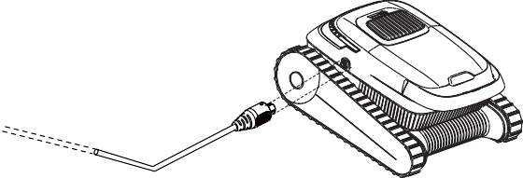
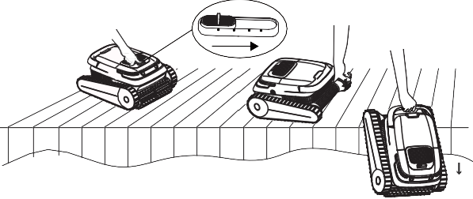
① Wählen Sie den gewünschten Reinigungsmodus und setzen Sie den Roboter möglichst gleich ins

Wasser.

OFF AUTO FLOOR WALL

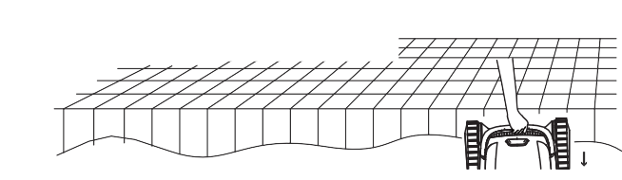
③ Entfernen Sie den Roboter aus dem Becken und schalten Sie ihn aus.
② Setzen Sie den Roboter langsam ins Wasser. Dann lässt der Roboter die Luft in seinem Körper ab und sinkt auf den Boden des Beckens.

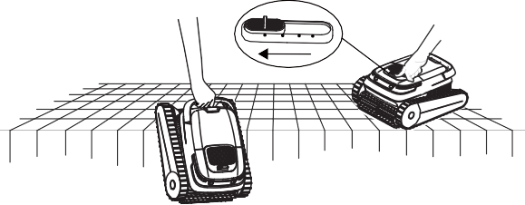
DE
OFF AUTO FLOOR WALL

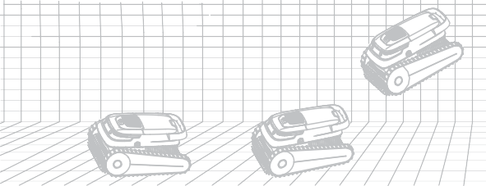
③ Der Roboter beginnt seine Arbeit innerhalb von 10 Sekunden nach Erreichen des Beckenbodens.

Reinigung des Filterkorbs
Es wird dringend empfohlen, den Filterkorb nach jedem Reinigungsvorgang zu reinigen.
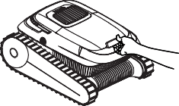
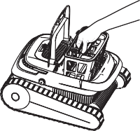
① Öffnen Sie die Abdeckung am Roboter. ② Entfernen Sie den Filterkorb.

4.4 Entnahme aus dem Schwimmbecken
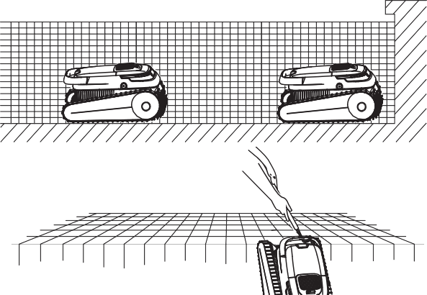
① Der Roboter hält automatisch am unteren Rand des Schwimmbeckens an, wenn die Reinigungsaufgabe abgeschlossen ist oder wenn der Akkustand niedrig ist.

② Verwenden Sie einen Haken, um den Roboter aus dem Becken zu holen.

③ Öffnen Sie den Deckel des Filterkorbs und entfernen Sie die Verunreinigungen.
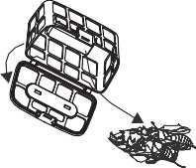

④ Spülen Sie den Filterkorb aus.
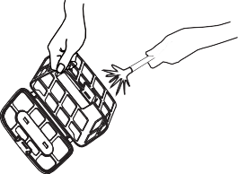

Hinweis: Bitte den Filterkorb häufig reinigen. Ein verstopfter Filter kann die gesamte Reinigungsleistung des Roboters beeinträchtigen, da er dann kaum Saugkraft erzeugen oder Schmutz und Ablagerungen im Filterkorb aufnehmen kann. Wenn die Reinigung keine Wirkung zeigt, muss der Filterkorb ausgetauscht werden.

Tägliche Wartung
Befolgen Sie diese Anweisungen zur Wartung des Roboters, um eine optimale Geräteleistung zu erzielen.

Nach dem täglichen Gebrauch
    - Den Roboter und den Filterkorb nach jeder Reinigung reinigen.
    - Von direktem Sonnenlicht fernhalten.
    - Überprüfen Sie vor dem Aufladen, ob der Ladeanschluss trocken ist.

Alle 3‒4 Monate oder nach einem Tiefenreinigungszyklus (wenn das Schwimmbecken verschmutzt ist)
    - Überprüfen Sie, ob sich Ablagerungen an den Walzenbürsten, Raupenketten und Antriebsrädern befinden.

Alle 12 Monate oder wenn der Roboter nur noch langsam arbeitet bzw. die Walzen sich langsam drehen.
    - Überprüfen Sie die Raupenketten und die Walzenbürsten auf Abnutzung und tauschen Sie sie aus.

Längere Lagerung außerhalb der Saison
Wenn der Roboter für längere Zeit nicht benutzt wird, sind die folgenden Schritte zur Vorbereitung der Lagerung erforderlich:
- Reinigen und trocknen Sie den Filterkorb, die Walzenbürsten und die Raupenketten gründlich.
- Überprüfen Sie, ob sich noch Restwasser im Pool-Reiniger befindet.
- Laden Sie den Roboter vor der Lagerung vollständig auf. Lagern Sie das Gerät an einen gut belüfteten, kühlen Ort mit einer Temperatur zwischen 5 und 45 °C und einer Luftfeuchtigkeit unter 80 % RH. Vermeiden Sie direkte Sonneneinstrahlung, Regen oder Frost.
② Entfernen Sie alle Silikon-Verschlüsse, ersetzen Sie das Walzenbürstenband durch ein neues, richten Sie die Silikon-Verschlüsse an den Befestigungsnuten aus und drücken Sie die Verschlüsse an, um sie in den Nuten zu fixieren.

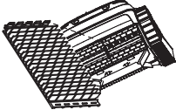
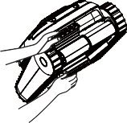
DE

7.2 Austausch der Raupenketten
① Entfernen Sie die Seitenteile: Entfernen Sie die beiden Schraubenabdeckungen. Lösen Sie mit einem Kreuzschlitzschraubendreher die beiden Schrauben, mit denen die Seitenteile und die Raupenkettenverkleidungen befestigt sind. Entfernen Sie die Seiten- und Raupenkettenverkleidungen und legen Sie sie beiseite.
② Reinigung: Reinigen Sie die Innenseite der Seitenteile und trocknen Sie sie mit einem Papiertuch oder Lappen.
③ Austausch: Ersetzen Sie die Raupenketten nach Bedarf.
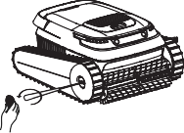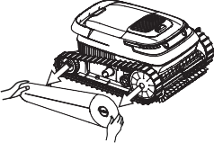

- Der Akku sollte mindestens alle 3 Monate aufgeladen werden, um eine Tiefentladung zu vermeiden.
- Lassen Sie den Roboter nicht in der Reichweite von Kindern oder Personen mit eingeschränkten körperlichen, sensorischen oder geistigen Fähigkeiten oder mangelnder Erfahrung und Kenntnis, es sei denn, sie werden beaufsichtigt oder unterwiesen.

Austausch von Ersatzteilen

Auswechseln der Walzenbürste
① Ziehen Sie auf der Rückseite des Walzenbürstenriemens die Silikon-Verschlüsse ab,
Entfernen Sie die Schraubenabdeckung und lösen Sie die Schrauben.
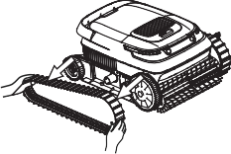
Entfernen Sie die Seitenteile:
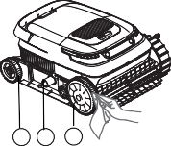

3 2 1

die diesen in den Befestigungsnuten fixieren. Entfernen der Raupenketten. Reinigen Sie die Innenseite der Seitenteile

Häufig gestellte Fragen (FAQs)
Wenn das Problem nach Umsetzung der vorgeschlagenen Lösungen weiterhin
DE besteht, wenden Sie sich an den Kundendienst.
Problem | Mögliche Ursachen | Lösungen
Der Roboter lädt nicht auf. | - Die Steckdose liefert keinen Strom. | - Überprüfen Sie, ob die Steckdose  korrekt funktioniert.
Der Roboter lädt nicht auf. | - Das Netzkabel ist nicht korrekt an die Steckdose angeschlossen. | - Überprüfen Sie die Verbindung zwischen dem Netzkabel und der Steckdose.
Der Roboter lädt nicht auf. | - Die Verbindung zwischen Netzadapter und Roboter ist lose. | - Überprüfen Sie die Verbindung zwischen dem Roboter und dem Netzadapter.
Der Roboter lädt nicht auf. | - Der Netzadapter funktioniert nicht. | - Überprüfen Sie, ob die Lade-LED leuchtet, wenn der Adapter an den Roboter angeschlossen ist. Wenn nicht, ersetzen Sie den Netzadapter (Ladegerät).
Der Roboter lädt nicht auf. | - Wasser ist in den Ladeanschluss eingedrungen. | - Trocknen Sie den Ladeanschluss und versuchen Sie erneut, den Roboter zu laden.
Der Roboter funktioniert nicht oder die LED-Anzeige leuchtet nicht. | - Die Akkuladung des Roboters ist nicht ausreichend. | - Verwenden Sie den Roboter erst, nachdem er vollständig aufgeladen wurde.
 | - Der Schalter des Roboters funktioniert nicht. | - Versuchen Sie, den Roboter aus und wieder einzuschalten.
Der Roboter klettert keine Wände hoch. | - Die Akkuleistung ist schwach. | - Verwenden Sie den Roboter erst, nachdem er vollständig aufgeladen wurde.
Der Roboter klettert keine Wände hoch. | - Überprüfen Sie, ob der Roboter auf den Bodenreinigungsmodus eingestellt ist und deshalb nur den Boden reinigt. | - In den Wandreinigungsmodus wechseln.
Der Roboter klettert keine Wände hoch. | - Der Filterkorb ist verstopft. | - Den Filterkorb reinigen.

Der Roboter klettert keine Wände hoch. | - An der Wand befinden sich Algen und der pH-Wert stimmt nicht. | - Den Gehalt an Chemikalien im Wasser überprüfen. Bei schlechter Wasserqualität können Algen wachsen, wodurch die Wände rutschig werden. In diesem Fall muss die Wasserqualität angepasst und die Wände geschrubbt werden.
Der Roboter klettert keine Wände hoch. | - Die Raupenketten und/oder Walzenbürsten sind abgenutzt. | - Ersetzen Sie die Raupenketten und/oder die Walzenbürsten.
Der Roboter bewegt sich im Kreis. | - Der Filterkorb ist verstopft. | - Den Filterkorb reinigen.
Der Roboter bewegt sich im Kreis. | - Verschmutzungen bleiben an den Raupenketten oder den Walzenbürsten hängen. | - Entfernen Sie Verschmutzungen von den Raupenketten oder Walzenbürsten. Anweisungen zum Austausch von Teilen finden Sie auf Seite 12.
Der Roboter hält unter Wasser an und die Fehleranzeige zeigt an, dass der Motor oder die Wasserpumpe blockiert ist. | - Verschmutzungen bleiben an den Raupenketten oder den Walzenbürsten hängen. | - Wenn der Motor blockiert ist, überprüfen Sie, ob die linke/rechte Raupenkette manuell gedreht werden kann. Ist dies nicht der Fall, überprüfen Sie, ob sich Hindernisse auf der Raupenkette befinden.
 | - Ablagerungen blockieren das Laufrad des Wasserpumpenmotors. | - Wenn der Wasserpumpenmotor blockiert ist, überprüfen Sie, ob sich Hindernisse auf den Laufrädern befinden.
Im neu gekauften Roboter befinden sich Wassertropfen und Schmutz. | - Alle Roboter werden vor Verlassen des Werks strengen Tests unterzogen, darunter auch Unterwassertests. Daher kann eine kleine Menge an Wassertröpfchen oder Schmutz im Inneren zurückbleiben. Der Roboter kann ganz normal benutzt werden. | - Dies hat keinen Einfluss auf den Betrieb des Roboters.

Contents
FR

AVERTISSEMENTS
Merci pour votre achat d’un nettoyeur de piscine robotisé Airrobo.
Veuillez lire attentivement ce manuel avant d’utiliser ce produit pour la première fois

- AVERTISSEMENTS P14-P15

- Liste de colisage........................................................................... P15-P15

- Aperçu du produit.......................................................................... P15-P16

- Instructions d'utilisation ...............................................................P16-P17

- Entretien quotidien.......................................................................P18-P18

- Stockage hors saison.....................................................................P18-P18

- Remplacement de pièces ..............................................................P18-P18

- FAQ..............................................................................................P19-P19
et conservez-le pour toute référence ultérieure.
- Ce produit n’est destiné qu’à un usage domestique et non à des fins commerciales ou FR
industrielles.
- Ce produit a subi des tests rigoureux avant de quitter l’usine, notamment des tests en immersion. C’est pourquoi il peut rester une petite quantité de gouttelettes d’eau ou de saletés à l’intérieur, ce qui n’affecte pas le fonctionnement du produit. N’hésitez pas à l’utiliser normalement.
- Ne faites pas fonctionner l’appareil lorsque des personnes ou des animaux se trouvent dans la piscine.
- Veuillez recharger complètement le robot avant sa première utilisation.
- Pour le chargement, utilisez uniquement l’adaptateur fourni avec le produit. N’utilisez jamais d’adaptateur de tiers. N’utilisez en aucun cas des câbles de rallonge. Lors du chargement, éloignez le produit des matériaux combustibles.
- N’utilisez pas d’adaptateur électrique endommagé pour charger le produit. Un cordon d’alimentation endommagé doit être remplacé par le fabricant, un agent de service ou une personne disposant de qualifications identiques. N’essayez jamais de réparer vous-même un cordon d’alimentation endommagé. Si une réparation est nécessaire, contactez-nous.
- Assurez-vous que le port de chargement est sec avant de connecter le produit à l’alimentation électrique.
- Veuillez charger le produit dans un endroit sûr, à l’abri de l’eau.
- Assurez-vous que la prise de courant est protégée par un disjoncteur de défaut de mise à la terre (GFI) ou par un disjoncteur de fuite à la terre.
- Ne rechargez pas et n’utilisez pas le robot si une anomalie est détectée. Veuillez contacter le service client.
- Ce robot n’est pas destiné à être utilisé par des personnes dont les capacités physiques, sensorielles ou mentales sont réduites ou manquant d’expérience et de connaissances (notamment les enfants), à moins qu’une personne responsable de leur sécurité ne les surveille ou ne leur ait fourni des instructions pour l’utilisation du robot.
- Les enfants doivent être surveillés pour s’assurer qu’ils ne jouent pas avec le robot.
- Le nettoyage et l’entretien ne doivent pas être assurés par des enfants sans surveillance.
- Tous les matériaux d’emballage doivent être éliminés correctement et conservés hors de portée des enfants et des animaux domestiques.

  - Ce produit contient une batterie non remplaçable. Ne démontez pas la batterie. Une fois la batterie en fin de vie, le robot doit être mis au rebut de manière appropriée.
  - N’essayez pas de réparer ou de modifier une quelconque partie de votre produit. Toutes les réparations ne doivent être effectuées que par du personnel qualifié. Aucune pièce réparable par l’utilisateur n’est incluse. Si une réparation est nécessaire, contactez-nous.
FR
  - Ce produit doit être entretenu par un professionnel qualifié ayant suﬃsamment d’expérience dans l’installation et l’entretien des équipements de piscine afin de s’assurer que toutes les instructions du manuel complet d’installation et d’utilisation peuvent être correctement respectées. Assurez-vous de respecter scrupuleusement toutes les consignes de sécurité figurant dans le manuel complet afin d’éviter tout risque de blessure. Aucune pièce réparable par l’utilisateur n’est incluse. N’hésitez pas à nous contacter si une réparation s’avère nécessaire.

Liste de colisage

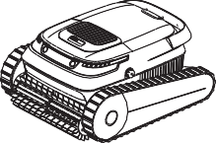
Nettoyeur de piscine robotisé (Avec filtre intégré) × 1

Adaptateur secteur × 1

Crochet × 1
Kit d’entretien × 1 Comprenant :

Kit d’entretien

Carte de garantie × 1

- Avant de procéder au nettoyage ou à l’entretien du robot, assurez-vous d’avoir
débranché la fiche d’alimentation de la prise de courant.
- Ne percez pas le boîtier du robot avec des clous ou tout autre objet pointu. Ne frappez pas le robot avec un marteau, ne lui donnez pas de coups et ne le jetez pas.
- N’exposez pas le produit ou la batterie à des températures excessives.
- Veillez à retirer la batterie du robot avant de le recycler ou de le mettre au rebut. Lors du retrait de la batterie, déconnectez toujours le robot de l’alimentation électrique.
- Veillez à éliminer ou à recycler les piles usagées conformément aux réglementations administratives locales. Consultez un organisme de recyclage professionnel si nécessaire.

Mode d’emploi × 1

- Aperçu du produit
Vis de machine combinée 1 × 2 pcs. Vis à métaux combinée 2 × 2 pcs. Poignée à boucle basculante × 1 pcs. Anneau de retenue × 4 pcs.
Vis autotaraudeuse 1 × 4 pcs. Vis autotaraudeuse 2 × 4 pcs. Bande de caoutchouc × 1 pcs. Rondelle × 4 pcs.

- Le joint de l’huile autour du moteur contient de la graisse, ce qui peut entraîner une légère pollution de l’eau si le moteur est endommagé. Si vous pensez que le produit présente une fuite, arrêtez immédiatement de l’utiliser.
- N’utilisez le robot que dans les conditions d’eau suivantes :
Sélection du mode de commutation/nettoyage

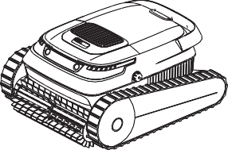
Sortie d’eau

Brosse du rouleau de nettoyage Port de chargement (avec capot de protection)
Chlore | 4 ppm max.
PH | 7,0 à 7,4
Température | 5 à 35 °C (41 à 95 °F)
Chlorure de sodium | 5 000 ppm max

Avant de charger Veuillez lire le manuel.

Profondeur maximale de travail：2.5m.
Bande lumineuse du témoin d’état

Instructions d’utilisation

Rechargement
    - Veuillez recharger complètement le robot avant sa première utilisation.
    - Retirez le robot de la piscine et éteignez-le.
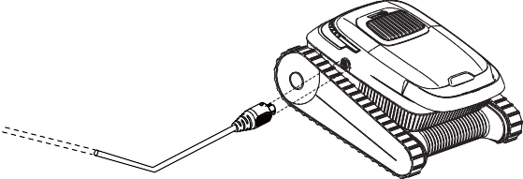
    - Vérifiez que le port de chargement est sec.
  - Témoins d’alimentation et d’état

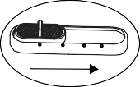
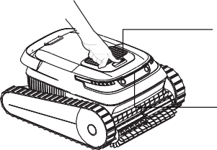
FR
OFF AUTO FLOOR WALL
LED
Dimensions applicables du bassin | piscine de 100 mètres carrés (1 076 pieds carrés)
Profondeur de la piscine | 0,5 à 2,5 m (1,64 à 8,2 pieds)
Dimensions du robotces | 475 × 395 × 250 mm/ 18,7 × 15,6 × 9,8 pou
Poids du robot | 9 kg/19,8 livres
Entrée du chargeur | 100 à 240 V, 50/60 Hz
Sortie du chargeur | 29.2 V 3 A (US: 29.4 V 3 A)
Entrée hôte | 29.2 V 3 A (US: 29.4 V 3 A)
Capacité de la batterie au lithium | 5.200 mAh
Durée de vie de la batterie | ≥ 2 heures
Durée de rechargement | 2,5 heures
Densité du filtre | 180 μm
Vitesse de déplacement | 10 à 15 m/min (32,8 à 49,2 pieds/min)
Indice d’étanchéité | IP68
Température de stockage | -20 bis +45 °C

DEL de couleur | État
Vert | Batterie suﬃsante
Bleu | Batterie insuﬃsante
Orange | Batterie très faible
Rouge | Panne

Mode de nettoyage
LOGO
Mode nettoyage |  | Zone de nettoyage
Nettoyage intelligent | A UTO | Nettoyer le sol/ les parois/la ligne d'eau
Nettoyage du sol | FLOOR | Ne nettoyer que le sol
Nettoyage de la paroi | WALL | Nettoyer les parois et la ligne d’eau
  - Mise à l’eau du robot
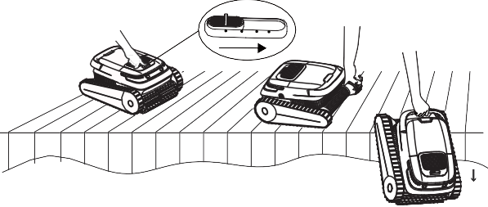
① Sélectionnez le mode de nettoyage désiré et mettez le robot dans l’eau dès que possible.
OFF AUTO FLOOR WALL

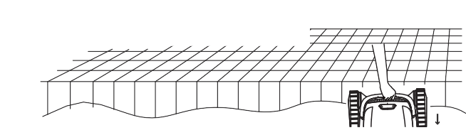
③ Retirez le robot de la piscine et éteignez-le.
② Mettez doucement le robot à l’eau. Le robot libère alors l’air contenu dans son corps et coule au fond de la piscine.

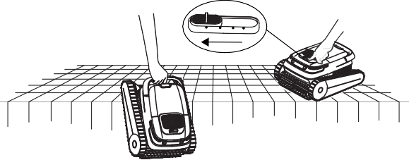
FR
OFF AUTO FLOOR WALL

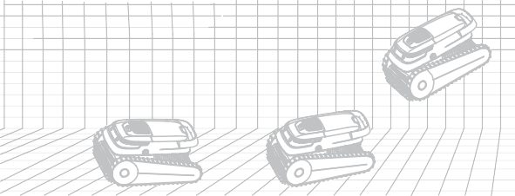
③ Le robot commence à travailler dans les 10 secondes qui suivent son arrivée au fond de la piscine.

Nettoyage du panier-filtre
Il est fortement recommandé de nettoyer le panier-filtre après chaque opération de nettoyage.
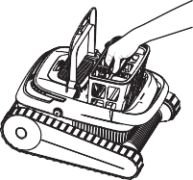
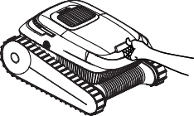
① Ouvrez le capot du compartiment du robot. ② Retirez le panier-filtre.

4.4 Sortie de la piscine
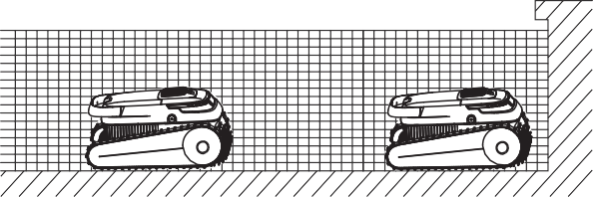
① Le robot s'arrête automatiquement au fond de la piscine une fois la tâche de nettoyage terminée ou lorsque la batterie est faible.

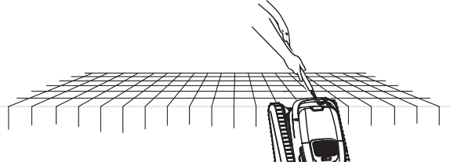
② Utilisez un crochet pour le sortir de la piscine.

③ Ouvrez le capot du panier-filtre et retirez les débris.

④ Rincez le panier-filtre.

Remarque : Veuillez nettoyer le panier-filtre dès que nécessaire. Un filtre obstrué peut affecter les performances globales de nettoyage du robot, en compliquant l’aspiration ou en retenant les saletés et les débris dans le panier-filtre. Si le nettoyage est sans effet, le panier-filtre doit être remplacé.

Maintenance quotidienne
Pour des performances optimales du produit, suivez ces instructions relatives à l’entretien du robot.

Après une utilisation quotidienne
    - Nettoyez le robot et le panier-filtre après chaque nettoyage.
    - Conservez à l’abri de la lumière directe du soleil.
    - Assurez-vous que le port de chargement est sec avant de procéder au chargement.

Tous les 3 à 4 mois ou après un cycle de nettoyage en profondeur (lorsque la piscine est sale)
    - Vérifiez qu’il n'y a pas de débris dans les brosses, les chenilles et les engrenages du rouleau.

Tous les 12 mois ou lorsque le robot fonctionne ou tourne lentement.
    - Vérifiez l’état d’usure des chenilles et des brosses des rouleaux et remplacez-les si nécessaire.

Stockage hors saison
Si le robot n’est pas utilisé pendant une longue période, procédez aux étapes de stockage suivantes :
- Nettoyez et séchez soigneusement le panier-filtre, les brosses du rouleau et les chenilles.
- Veillez à ce qu'il n’y ait pas d’eau résiduelle dans le nettoyeur.
- Chargez complètement le robot avant de le ranger. Placez-le dans un endroit frais et bien ventilé, à une température comprise entre 5 et 45 °C (41 et 113 °F) et à une humidité inférieure à 80 % HR. Évitez la lumière directe du soleil, la pluie ou le gel.
- La batterie doit être rechargée au moins tous les 3 mois pour éviter une décharge excessive.
- Ne laissez pas le robot à la portée d’enfants ou de personnes dont les capacités physiques, sensorielles ou mentales sont réduites ou qui manquent d’expérience et de connaissances, à moins qu’ils ne soient surveillés ou qu’ils n’aient reçu des instructions.

Remplacement de pièces

Remplacement d'une brosse du rouleau
① Au dos de la courroie des brosses du rouleau, détachez les boucles en silicone qui fixent les rainures de montage.
② Retirez toutes les boucles en silicone, remplacez la courroie des brosses du rouleau par une nouvelle, alignez les boucles en silicone avec les rainures de montage et appuyez sur les boucles pour les fixer dans les rainures.

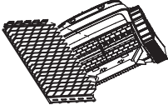
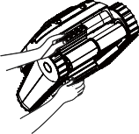
FR

Remplacement d’une chenille
① Retirez les panneaux latéraux :
Retirez les deux cache-vis. À l’aide d’un tournevis cruciforme, dévissez les deux vis qui maintiennent les panneaux latéraux et les panneaux des chenilles en place. Retirez les panneaux latéraux et les panneaux des chenilles puis mettez-les de côté.
② Nettoyez : Nettoyez l’intérieur des panneaux latéraux et séchez-les avec une serviette en papier ou un chiffon.
③ Remplacez : Si nécessaire, remplacez la chenille.
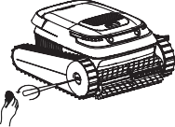
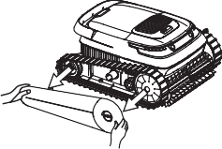
Retirez le cache-vis et dévissez les vis. Retirez les panneaux latéraux
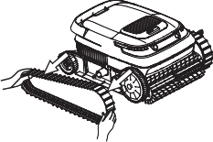
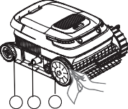

3 2 1
Retirez les chenilles. Nettoyer l'intérieur des panneaux latéraux

8.FAQ
Si un problème persiste après la mise en œuvre des solutions suggérées, contactez le support à la clientèle pour obtenir une assistance.
FR
Problème | Causes possibles | Solutions
Le robot ne se recharge pas. | - La prise de courant n’est pas  alimentée. | - Vérifiez si la prise de courant  fonctionne.
Le robot ne se recharge pas. | - Le cordon d’alimentation n’est pas correctement connecté à la prise de courant. | - Vérifiez la connexion entre le cordon d’alimentation et la prise de courant.
Le robot ne se recharge pas. | - La connexion entre l’adaptateur d’alimentation et le robot est desserrée. | - Vérifiez la connexion entre le robot et l’adaptateur.
Le robot ne se recharge pas. | - L’adaptateur électrique ne fonctionne pas. | - Vérifiez si le voyant de recharge s’aﬃche lorsque l’adaptateur est connecté au robot. Si tel n’est pas le cas, remplacez le chargeur.
Le robot ne se recharge pas. | - De l’eau est entrée dans le port de chargement. | - Séchez le port de chargement et essayez à nouveau de recharger.
Le robot ne fonctionne pas ou le témoin ne s’allume pas. | - Le robot n’a pas assez de batterie. | - Rechargez complètement le robot avant de l’utiliser.
Le robot ne fonctionne pas ou le témoin ne s’allume pas. | - L’interrupteur du robot est défectueux. | - Essayez d’éteindre et de rallumer le robot.
Le robot n’escalade pas les parois. | - La batterie est faible. | - Rechargez complètement le robot avant de l’utiliser.
Le robot n’escalade pas les parois. | - Vérifiez que le robot fonctionne en mode de nettoyage du sol et qu’il ne nettoie que le sol. | - Passez en mode de nettoyage des parois.
Le robot n’escalade pas les parois. | - Le panier-filtre est obstrué. | - Nettoyez le panier-filtre.

Le robot n’escalade pas les parois. | - Il y a des algues sur la paroi et la valeur du pH n’est pas correcte. | - Vérifiez les niveaux de produits chimiques dans l’eau. Une mauvaise qualité de l’eau peut entraîner la prolifération d’algues et rendre les parois glissantes. Il faut alors régler la qualité de l’eau et frotter les parois.
Le robot n’escalade pas les parois. | - Les chenilles et/ou les brosses des rouleaux sont usées. | - Remplacez les chenilles et/ou les brosses des rouleaux.
Le robot se déplace en cercles. | - Le panier-filtre est obstrué. | - Nettoyez le panier-filtre.
Le robot se déplace en cercles. | - Il reste des débris coincés sur les chenilles ou les brosses des rouleaux. | - Retirez les débris des chenilles ou des brosses des rouleaux. Consultez la page 18 pour les instructions relatives au remplacement des pièces.
Le robot s’arrête sous l’eau et le témoin de défaut indique que le moteur ou la pompe à eau est bloqué. | - Il reste des débris coincés sur les chenilles ou les brosses des rouleaux. | - Si le moteur est bloqué, vérifiez si la chenille gauche/droite peut être tournée manuellement. Dans le cas contraire, vérifiez qu’il ne subsiste aucune obstruction sur la chenille.
 | - Des débris bloquent la roue du moteur de la pompe à eau. | - Si le moteur de la pompe à eau est bloqué, vérifiez qu'il n’y a pas d’obstacles sur les rotors.
Il y a des gouttes d'eau et de la saleté dans le robot nouvellement acheté. | - Chaque robot a subi des tests rigoureux avant de quitter l’usine, notamment des tests sous l’eau. Il est donc possible qu’une petite quantité de gouttelettes d’eau ou de saletés subsiste à l’intérieur. N’hésitez pas à utiliser le robot normalement. | - Cela n’affecte pas le fonctionnement du robot.

Contents

IT
- AVVERTENZE
Grazie per aver scelto di acquistare il Robot da piscina Airrobo.

- AVVERTENZE P20-P21

- Contenuto della confezione...........................................................P21-P21

- Panoramica del prodotto................................................................P21-P22

- Istruzioni per l'uso........................................................................P22-P23

- Manutenzione quotidiana..............................................................P24-P24

- Conservazione fuori stagione.........................................................P24-P24

- Sostituzione delle parti................................................................. P24-P24

- Domande frequenti ....................................................................... P25-P25
Si prega di leggere con attenzione il presente manuale prima di iniziare a utilizzare il prodotto. Consigliamo inoltre di conservarlo per consultarlo in futuro.
- Questo prodotto è destinato esclusivamente all'uso domestico e non a scopi commerciali IT
o industriali.
- Prima di uscire dalla fabbrica, questo prodotto è stato sottoposto a rigorosi test, compresi test subacquei. Ecco perché all'interno ci potrebbero essere alcune gocce d'acqua o di sporcizia. Ciò non influisce sul funzionamento del prodotto. Non esitare a utilizzarlo in modo normale.
- Non utilizzare il dispositivo in presenza di persone o animali nella piscina.
- Caricare completamente il robot prima di iniziare a utilizzarlo.
- Per la ricarica, servirsi esclusivamente dell'adattatore fornito in dotazione con il prodotto. Non utilizzare mai un adattatore di terze parti. Non utilizzare in nessun caso cavi di prolunga. Durante l’operazione di ricarica, tenere il prodotto lontano da materiali combustibili.
- Non utilizzare un adattatore danneggiato per caricare il prodotto. Un cavo di alimentazione danneggiato deve essere sostituito dal produttore, da un agente di assistenza o da personale con qualifiche simili. Non cercare mai di riparare da soli un cavo di alimentazione danneggiato. Qualora sia necessario eseguire un intervento di riparazione vi invitiamo a contattarci.
- Accertarsi che la porta di ricarica sia asciutta prima di collegare il prodotto all'alimentazione.
- Caricare il prodotto in un luogo sicuro e lontano dall'acqua.
- Accertarsi che la presa di corrente sia protetta da un interruttore di terra (GFI - ground fault interrupter) o da un interruttore di dispersione a terra.
- Non caricare o utilizzare il robot quando viene rilevata un'anomalia. Contattare l’assistenza clienti.
- Questo robot non è destinato all'uso da parte di persone con ridotte capacità fisiche, sensoriali o mentali o con scarsa esperienza e conoscenza (compresi i bambini), a meno che non sia stata fornita loro una supervisione o istruzioni per l'uso del robot da parte di una persona responsabile della loro sicurezza.
- I bambini devono essere sorvegliati per evitare che giochino con il robot.
- Le operazioni di pulizia e manutenzione non devono essere eseguite da bambini senza supervisione.

- Tutti i materiali di imballaggio devono essere smaltiti correttamente e tenuti lontani da bambini e animali domestici.
- Questo prodotto contiene una batteria non sostituibile. Non smontare la batteria. Al
termine della durata della batteria, è opportuno procedere al corretto smaltimento del robot.
- Non cercare di riparare o modificare nessuna parte del prodotto. Tutte le riparazioni devono essere effettuate esclusivamente da personale qualificato. Il prodotto non contiene parti
- Contenuto della confezione

IT
riparabili dall'utente. Qualora sia necessario eseguire un intervento di riparazione

vi invitiamo a contattarci.
- La manutenzione di questo prodotto deve essere effettuata da un professionista qualificato con suﬃciente esperienza nel settore dell'installazione e della manutenzione di attrezzature per piscine, in modo da poter seguire in modo accurato tutte le istruzioni contenute nel manuale completo di installazione e funzionamento. Accertarsi di seguire esplicitamente tutte le istruzioni di sicurezza contenute nel manuale completo per evitare il rischio di lesioni. Il prodotto non contiene parti riparabili dall'utente. Qualora necessitiate di un intervento di riparazione vi invitiamo a contattarci.
- Prima di procedere alla pulizia o alla manutenzione del robot, accertarsi di scollegare la spina dalla presa di corrente.
- Non forare l'involucro del robot con chiodi o altri oggetti appuntiti. Non picchiare con il martello, colpire o lanciare il robot.
- Non esporre il prodotto o la batteria a temperature eccessive.
- Accertarsi di rimuovere la batteria dal robot prima di procedere al suo riciclaggio o smaltimento. Quando viene rimossa la batteria, scollegare sempre il robot dall'alimentazione.
- Smaltire o riciclare le batterie usate in conformità con le normative amministrative locali. Ove necessario, rivolgersi a un'agenzia di riciclaggio professionale.
- L'olio di tenuta intorno al motore contiene grasso, che può causare un leggero inquinamento dell'acqua se il motore è danneggiato. Se si ritiene che ci sia una perdita, interrompere immediatamente l'uso del prodotto.
- Utilizzare il robot solo nelle seguenti condizioni idriche:
Antes de cargar
Cloro | Max 4 ppm
PH | 7.0-7.4
Temperatura | 5-35°C (41-95°F)
Cloruro di sodio | Max 5.000 ppm

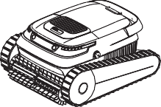
- Panoramica del prodotto
Robot da piscina (Con filtro integrato) × 1
Adattatore di Scheda di
corrente × 1 Gancio × 1 garanzia × 1
Kit di manutenzione × 1 Comprensivo di: Vite macchina combinata 1 × 2 pezzi. Vite macchina combinata 2 × 2 pezzi. Chiusura con fibbia a ribalta × 1 pezzi. Vite auto-filettante 1 × 4 pezzi.
Vite autofilettante 2 × 4 pezzi.
Manuale Utente × 1 Anello di sicurezza × 4 pezzi. Nastro di gomma × 1 pezzi. Rondella × 4 pezzi.

Kit di manutenzione
Cambia/Selezione della modalità di pulizia

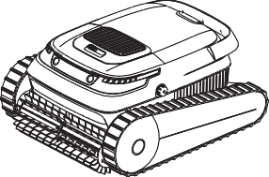
Uscita dell’acqua

Por favor, lea el manual.
Pulizia della spazzola a rullo
Porta di ricarica (con coperchio protettivo)

Profundidad máxima de trabajo：2.5m.
Striscia luminosa spia di stato

4.2 Spie di alimentazione e di stato
Dimensioni di piscina applicabili | Piscina di 1,076 piedi quadrati (100 metri quadrati)
Profondità della piscina | 0,5-2,5 m (1,64-8,2 ft)
Dimensioni del robot | 475 × 395 × 250 mm/18,7 × 15,6 × 9,8 pollici
Peso del robot | 9 kg/19.8 lbs
Ingresso del caricatore | 100-240 V, 50/60 Hz
Uscita del caricatore | 29.2 V | 3 A (US: 29.4 V | 3 A)
Entrada host | 29.2 V | 3 A (US: 29.4 V | 3 A)
Capacità della batteria al litio | 5.200 mAh
Durata di vita della batteria | ≥ 2 ore
Tempo di ricarica | 2,5 ore
Densità del filtro | 180 μm
Velocità di spostamento | 10-15 m/min (32,8-49,2 ft/min)
Grado di impermeabilità | IP68
Temperatura di conservazione | Da -20°C a +45°C

Colore del LED | Stato
Verde | Batteria suﬃciente
Blu | Batteria insuﬃciente
Arancione | Batteria eccessivamente scarica
Rosso | Guasto

IT

Istruzioni per l＇uso

Ricarica
    - Caricare completamente il robot prima di iniziare a utilizzarlo.
    - Rimuovere il robot dalla piscina e spegnerlo.
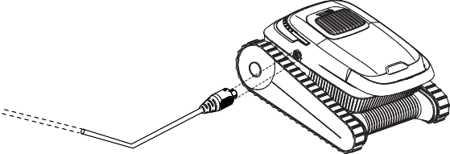
    - Accertarsi che la porta di ricarica sia asciutta.

4.3 Modo de limpieza

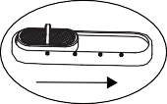
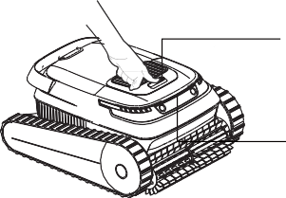
4.4 Mettere il robot in acqua
OFF AUTO FLOOR WALL
LED
LOGO
Modalità di pulizia |  | Area di pulizia
Pulizia intelligente | A UTO | Pulire il pavimento/le pareti/la linea dell’acqua
Pulizia del pavimento | FLOOR | Pulire solo il pavimento
Pulizia della parete | WALL | Pulire solo la parete

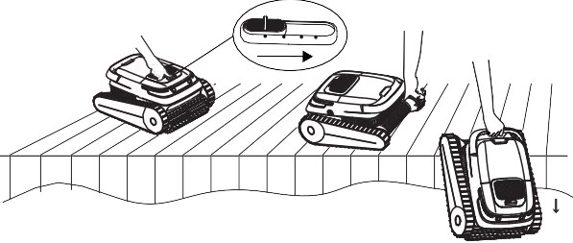
① Selezionare la modalità di pulizia desiderata e mettere il robot in acqua il prima possibile.

OFF AUTO FLOOR WALL

③ Rimuovere il robot dalla piscina e spegnerlo.
② Inserire lentamente il robot nell'acqua. Quindi, il robot rilascerà l'aria contenuta nel corpo e affonderà sul fondo della piscina.

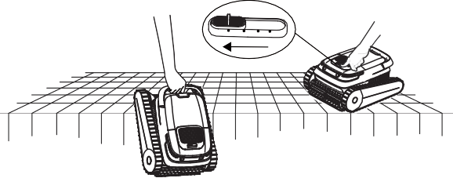
IT
OFF AUTO FLOOR WALL

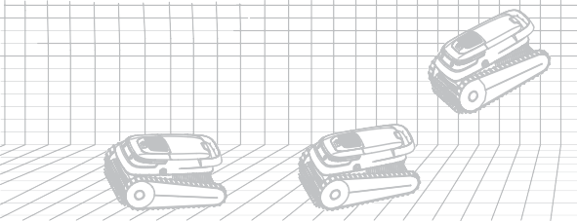
③ Il robot inizierà a lavorare entro 10 secondi dal raggiungimento del fondo della piscina.

4.5 Pulizia del contenitore del filtro
EConsigliamo vivamente di pulire il contenitore del filtro dopo ogni operazione di pulizia.
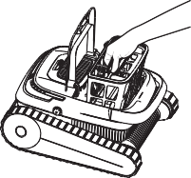
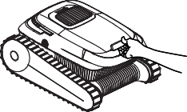
① Aprire il coperchio del vano robot. ② Togliere il contenitore del filtro.

4.4 Estrazione dalla piscina
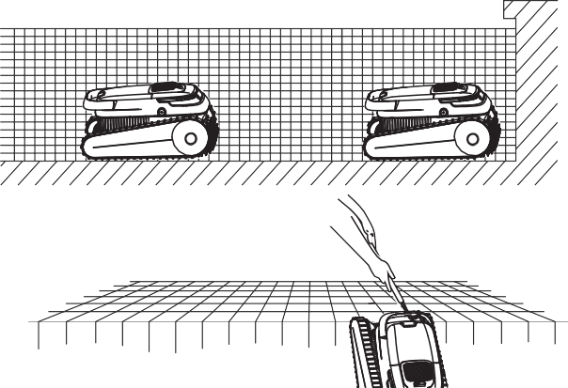
① Il robot si ferma automaticamente sull’estremità inferiore della piscina al termine dell'operazione di pulizia o quando il livello di alimentazione della batteria è basso.

③ Aprire il coperchio del contenitore del filtro ed eliminare la sporcizia.

④ Risciacquare il contenitore del filtro.

② VUsare un gancio per sollevare il robot dalla piscina.

Nota: Pulire il contenitore del filtro per tempo. Un filtro intasato può influire sulle prestazioni di pulizia complessive del robot, rendendo diﬃcile la generazione di potenza aspirante o la cattura di sporcizia e residui nel contenitore del filtro. Se la pulizia non ha effetto, sarà necessario provvedere alla sostituzione del contenitore del filtro.

Manutenzione giornaliera
Al fine di garantire prestazioni ottimali del prodotto, rispettare le seguenti istruzioni per la manutenzione del robot.

Dopo l'uso quotidiano
    - Pulire il robot e il contenitore del filtro dopo ogni pulizia.
    - Tenere lontano dalla luce solare diretta.
    - Accertarsi che la porta di ricarica sia asciutta prima di avviare l’operazione di ricarica.

Ogni 3-4 mesi o dopo un ciclo di pulizia profonda (quando la piscina è sporca)
    - Verificare che non vi sia sporcizia nelle spazzole a rullo, nei cingoli e negli ingranaggi.

Ogni 12 mesi o quando si riscontra che il robot funziona/ruota lentamente
    - Verificare che i cingoli e le spazzole a rullo non siano usurati. Se sono usurati, sostituirli.

Conservazione fuori stagione
Se il robot non viene utilizzato per un lungo periodo di tempo, eseguire le seguenti operazioni di stoccaggio:
- Pulire e asciugare accuratamente il contenitore del filtro, le spazzole a rullo e i cingoli.
- Accertarsi che non vi siano residui d'acqua nel robot da piscina.
- Caricare completamente il robot prima di riporlo. Collocarlo in un luogo fresco e ben ventilato con una temperatura compresa tra 5°C e 45°C (41°F e 113°F) e un'umidità inferiore all'80% Umidità Relativa. Evitare la luce solare diretta, la pioggia o il gelo.
- Sarà necessario caricare la batteria almeno ogni 3 mesi per evitare che si scarichi eccessivamente.
- Non lasciare il robot alla portata di bambini o di persone con ridotte capacità fisiche, sensoriali o mentali o con mancanza di esperienza e conoscenza, a meno che non siano state fornite loro supervisione o istruzioni.

Sostituzione delle parti

Sostituzione della spazzola a rullo
① Sul retro del nastro della spazzola a rullo, staccare le fibbie in silicone che fissano le scanalature di montaggio.
② Rimuovere tutte le fibbie in silicone, sostituire la cinghia della spazzola a rullo con una nuova, allineare le fibbie in silicone alle scanalature di montaggio e premere le fibbie per fissarle nelle scanalature.

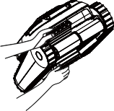
IT

Sostituzione dei cingoli
① Rimuovere i pannelli laterali: Rimuovere i due coperchi delle viti. Con un cacciavite Phillips, svitare le due viti che tengono in posizione i pannelli laterali e i pannelli dei cingoli. Rimuovere i pannelli laterali e i pannelli dei cingoli e metterli da parte.
② Pulire: Pulire l'interno dei pannelli laterali e asciugarli con un panno o un asciugamano di carta.
③ Sostituire:
Sostituire i cingoli all’occorrenza.
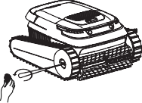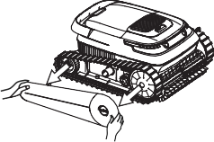
Rimuovere il coperchio delle viti e svitare le viti. imuovere i pannelli laterali
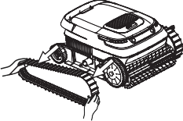
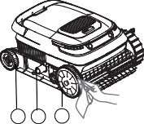

3 2 1
Rimuovere i cingoli. Reinigen See die innenseite der seinteile

Domande più frequenti
Se il problema persiste anche dopo l'applicazione delle soluzioni suggerite, contattare l'assistenza clienti per ricevere assistenza.

IT
Problema | Possibili cause | Soluzioni
Il robot non si carica. | - La presa di corrente non è  alimentata. | - Verificare se la presa di corrente  funziona.
Il robot non si carica. | - Il cavo di alimentazione non è collegato correttamente alla presa di corrente. | - Controllare il collegamento tra il cavo di alimentazione e la presa di corrente.
Il robot non si carica. | - Il collegamento tra l'adattatore di alimentazione e il robot è allentato. | - Controllare il collegamento tra il robot e l'adattatore.
Il robot non si carica. | - L'adattatore di alimentazione non funziona. | - Controllare se il LED di carica è visualizzato quando l'adattatore è collegato al robot. In caso contrario, sostituire il caricabatterie.
Il robot non si carica. | - È entrata dell’acqua nella porta di ricarica. | - Asciugare la porta di ricarica e provare nuovamente a caricare.
Il robot non funziona o la spia non si accende. | - La batteria del robot non è suﬃciente. | - Utilizzare il robot dopo averlo caricato completamente.
Il robot non funziona o la spia non si accende. | - L'interruttore del robot non funziona. | - Provare a spegnere e riaccendere il robot.
Il robot non sale sulle pareti. | - La batteria è scarica. | - Utilizzare il robot dopo averlo caricato completamente.
Il robot non sale sulle pareti. | - Verificare se il robot funziona in modalità di pulizia del pavimento e se pulisce solo il pavimento. | - Passare alla modalità di pulizia delle pareti.
Il robot non sale sulle pareti. | - Il contenitore del filtro è ostruito. | - Pulire il contenitore del filtro.

Il robot non sale sulle pareti. | - Ci sono alghe sulla parete e il valore del pH non è corretto. | - Verificare i livelli di sostanze chimiche nell'acqua. Una cattiva qualità dell'acqua può consentire la crescita di alghe, rendendo le pareti scivolose. In questo caso, regolare la qualità dell'acqua e pulire le pareti.
Il robot non sale sulle pareti. | - I cingoli e/o le spazzole a rullo sono usurati. | - Sostituire i cingoli e/o le spazzole a rullo.
Il robot si muove in cerchio. | - Il contenitore del filtro è ostruito. | - Pulire il contenitore del filtro.
Il robot si muove in cerchio. | - La sporcizia si incastra sui cingoli o sulle spazzole a rullo. | - Rimuovere la sporcizia dai cingoli o dalle spazzole a rullo. Consultare pagina 24 per le istruzioni sulla sostituzione delle parti.
Il robot si ferma sott'acqua e la spia di guasto indica che il motore o la pompa dell'acqua sono bloccati. | - La sporcizia si incastra sui cingoli o sulle spazzole a rullo. | - Se il motore è bloccato, verificare se è possibile ruotare manualmente il cingolo destro/sinistro. In caso contrario, verificare che non vi siano ostruzioni sul cingolo.
 | - La sporcizia blocca la girante del motore della pompa dell'acqua. | - Se il motore della pompa dell'acqua è bloccato, verificare la presenza di ostacoli sulle giranti.
Nel robot appena acquistato sono presenti gocce d'acqua e sporcizia. | - Prima di uscire dalla fabbrica, ogni robot è stato sottoposto a rigorosi test, compresi test subacquei. Per questo motivo è possibile che all'interno vi sia una piccola quantità di gocce d'acqua o di sporcizia. Non esitare a utilizzare il robot in modo normale.anz normal benutzt werden. | - Ciò non influisce sul funzionamento del robot.

Catálogo
ES

ADVERTENCIAS
Gracias por adquirir el Robot limpiador de piscinas Airrobo.

- ADVERTENCIAS P26-P27

- Lista de empaque......................................................................... P27-P27

- Resumen del producto................................................................... P27-P28

- Instrucciones de uso..................................................................... P28-P29

- Mantenimiento diario................................................................... P30-P30

- Almacenamiento fuera de temporada............................................ P30-P30 7.Sustitución de piezas ....................................................................P30-P30
8.Preguntas frecuentes..................................................................... P31-P31
Lea atentamente este manual antes de utilizar el producto por primera vez y consérvelo para consultas futuras.
- Este producto está destinado solo para uso doméstico y no para fines comerciales o industriales.
- Se ha sometido a este producto a rigurosas pruebas antes de salir de fábrica, entre ellas ES
pruebas bajo el agua. Por lo tanto, puede haber quedado una pequeña cantidad de gotas de agua o suciedad en su interior, que no afectará al funcionamiento del producto. No dude en utilizarlo con normalidad.
- No utilice el aparato cuando haya personas o animales en la piscina.
- Cargue el robot por completo antes de utilizarlo por primera vez.
- Para cargarlo, utilice solo el adaptador suministrado con el producto. No utilice nunca adaptadores de otros fabricantes. No utilice cables alargadores bajo ninguna circunstancia. Mantenga el producto alejado de materiales combustibles durante la carga.
- No utilice un adaptador de corriente dañado para cargar el producto. El fabricante, un agente de servicio o personal con cualificaciones similares debe sustituir un cable de alimentación dañado. No intente reparar usted mismo un cable de alimentación dañado. Si necesita repararlo, póngase en contacto con nosotros.
- Asegúrese de que el puerto de carga esté seco antes de conectar el producto a la red eléctrica.
- Cargue el producto en un lugar seguro y alejado del agua.
- Asegúrese de que la toma de corriente esté protegida por un interruptor diferencial (GFI, por sus siglas en inglés) o un disyuntor de fugas a tierra.
- No cargue ni utilice el robot si detecta alguna anomalía. Póngase en contacto con el servicio de atención al cliente.
- Este robot no está diseñado para su uso por parte de personas con capacidades físicas, sensoriales o mentales reducidas ni con falta de experiencia y conocimientos (incluidos los niños), a menos que hayan recibido supervisión o instrucciones para el uso del robot por parte de una persona responsable de su seguridad.
- Se debe supervisar a los niños para asegurarse de que no jueguen con el robot.
- Los niños no deben realizar la limpieza ni el mantenimiento sin supervisión.
- Todos los materiales de embalaje deben desecharse de forma adecuada y mantenerse fuera del alcance de niños y animales domésticos.

  - Este producto contiene una batería que no se puede sustituir. No desmonte la batería. Cuando finalice la vida útil de la batería, el robot debe desecharse de forma adecuada.
  - No intente reparar ni modificar ninguna pieza del producto. Solo el personal cualificado debe realizar todas las reparaciones. No se incluyen piezas reparables por el usuario. Si necesita repararlo, póngase en contacto con nosotros.
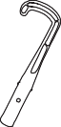
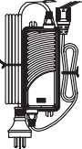
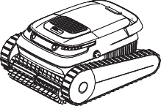
  - Un profesional cualificado con suficiente experiencia en la instalación y el mantenimiento de equipos de piscinas debe realizar el mantenimiento de este producto para que se .

Lista de empaque

ES puedan seguir con precisión todas las instrucciones del manual completo de instalación

y funcionamiento. Asegúrese de seguir de forma explícita todas las instrucciones de
seguridad del manual completo para evitar el riesgo de lesiones. No se incluyen piezas
Robot limpiador de piscinas (Con filtro incorporado) × 1
Adaptador de corriente × 1

Gancho × 1
Tarjeta de garantía × 1

reparables por el usuario. Póngase en contacto con nosotros cuando necesite servicios
de reparación.
- Antes de limpiar el robot o realizarle tareas de mantenimiento, asegúrese de desconectar el enchufe de la toma de corriente.
- No perfore la carcasa del robot con clavos u otros objetos afilados. No martillee, golpee ni lance el robot.
- No exponga el producto ni la batería a temperaturas excesivas.
- Asegúrese de extraer la batería del robot antes de reciclarlo o desecharlo. Cuando retire la batería, desconecte siempre el robot de la fuente de alimentación.

Manual del usuario × 1
Kit de mantenimiento × 1 Incluye:
Tornillo de máquina combinado 1 × 2 pzas. Tornillo de máquina combinado 2 × 2 pzas. Pieza de mano con hebilla abatible × 1 pzas. Arandela × 4 pzas. Circlip × 4 pzas.

Assemblaggio
Tornillo autorroscante 1 × 4 pzas. Tornillo autorroscante 2 × 4 pzas. Tiras de Goma × 1 pzas.

- Deseche o recicle las baterías usadas de acuerdo con la normativa administrativa local. Si es necesario, consulte a una agencia de reciclaje profesional.
- El sellado de aceite alrededor del motor contiene grasa, que puede causar una pequeña contaminación del agua si el motor se daña. Si cree que hay una fuga, deje de utilizar el producto de inmediato.
- Solo utilice el robot en las siguientes condiciones de agua:
- Descripción general del producto
Interruptor FS/Selección del modo de limpieza

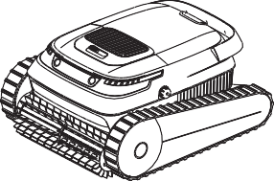
Salida de agua

Cepillo del rodillo de limpieza Puerto de carga (con cubierta protectora)
Cloro | Máx. 4 ppm
PH | 7,0-7,4
Temperatura | 5-35 °C (41-95 °F)
Cloruro sódico | Máx. 5000 ppm

Vor dem auflan Bitte Lesen si die anleitung.

Maximale Hausaufgabentiefe：2.5m.
Indicador luminoso de estado

4.2 Indicadores de encendido y estado
Tamaño de piscina aplicable | Piscina de 100 metros cuadrados (1076 pies cuadrados)
Profundidad de la piscina | 0,5-2,5 m (1,64-8,2 ft)
Dimensiones del robot | 475 × 395 × 250 mm/18,7 × 15.6 × 9,8 in
Peso del robot | 9 kg/19,8 lb
Entrada del cargador | 100-240 V~50/60 Hz
Salida del cargador | 29.2 V 3 A (US: 29.4 V 3 A)
Ingresso host | 29.2 V 3 A (US: 29.4 V 3 A)
Capacidad de la batería de litio | 5.200 mAh
Duración de la batería | ≥2 horas
Tiempo de carga | 2,5 horas
Densidad del filtro | 180 μm
Velocidad de desplazamiento | 10‒15 m/min
Índice de impermeabilidad | IP68
Temperatura de almacenamiento | -20 °C a +45 °C

Color de LED | Estado
Verde | Batería suficiente
Azul | Batería insuficiente
Naranja | Batería muy baja
Rojo | Fallo

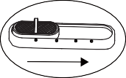
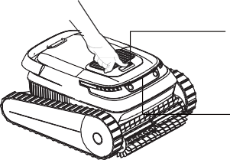
ES

OFF

AUTO

FLOOR WALL

Instrucciones de uso

Carga
    - Cargue el robot por completo antes de utilizarlo por primera vez.
    - Retire el robot de la piscina y apáguelo.
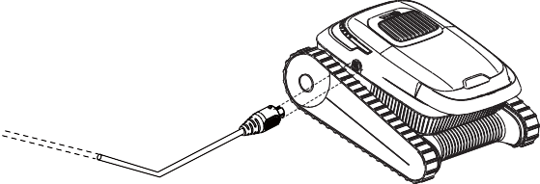
    - Asegúrese de que el puerto de carga esté seco.

Modalità di pulizia

  - Colocación del robot en el agua
LOGO
Modo de limpieza |  | Área de limpieza
Limpieza inteligente | A UTO | Limpiar el suelo/pared/ línea de agua
Limpieza del suelo | FLOOR | Limpiar solo el suelo
Limpieza de pared | WALL | Limpiar la pared y la línea  de agua

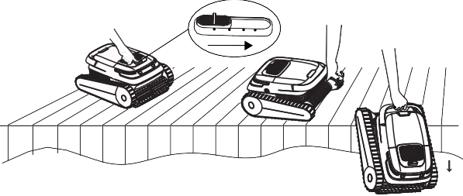
① Elija el modo de limpieza deseado y coloque el robot en el agua lo antes posible.

OFF AUTO FLOOR WALL
LED

ES
② Introduzca lentamente el robot en el agua. A continuación, el robot soltará el aire del cuerpo y se hundirá hasta el fondo de la piscina.

③ El robot empezará a funcionar 10 segundos
③ Retire el robot de la piscina y apáguelo.

después de llegar al fondo de la piscina.

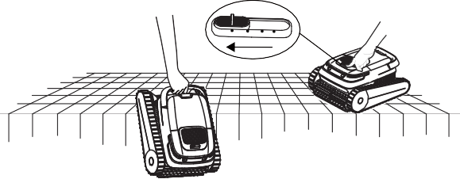
Limpieza de la cesta del filtro
OFF AUTO FLOOR WALL
Recomendamos limpiar la cesta del filtro después de cada tarea de limpieza.

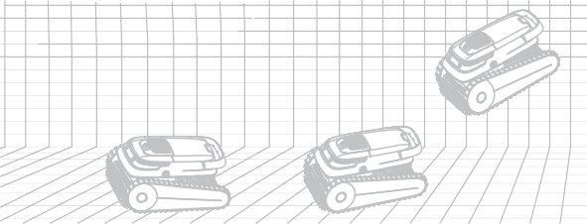
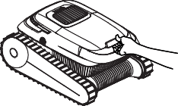
① Abra la cubierta del compartimento del robot.
② Retire la cesta del filtro.

4.4 Retiro de la piscina
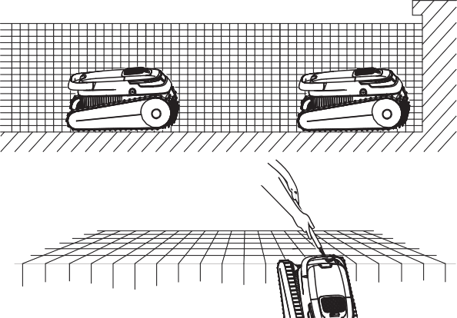
① El robot se detendrá de forma automática en el borde inferior de la piscina una vez finalizada la tarea de limpieza o cuando la carga de la batería sea baja.

② Utilice un gancho para sacarlo de la piscina.

③ Abra la cubierta de la cesta del filtro y retire los residuos.

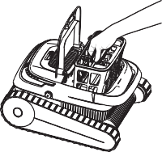
④ Enjuague la cesta del filtro.

Nota: Limpie la cesta del filtro a tiempo. Un filtro obstruido puede afectar al rendimiento general de limpieza del robot, y dificultar que genere succión o atrape la suciedad y los residuos en la cesta del filtro. Si la limpieza no surte efecto, es necesario sustituir la cesta del filtro.

Mantenimiento diario
Para un rendimiento óptimo del producto, siga estas instrucciones para mantener el robot.
② Retire todas las hebillas de silicona, sustituya la correa de los cepillos de los rodillos por una nueva, alinee las hebillas de silicona con las ranuras de montaje y presione las hebillas para fijarlas en las ranuras.

Después del uso diario
    - Limpie el robot y la cesta del filtro después de cada limpieza.
    - Manténgalo alejado de la luz solar directa.
    - Asegúrese de que el puerto de carga esté seco antes de cargarlo.

Cada 3 o 4 meses o después de un ciclo de limpieza profunda (cuando la piscina esté sucia)
    - Compruebe que no haya residuos en los cepillos de los rodillos, las orugas y los engranajes.

Cada 12 meses o cuando se detecte que el robot funciona/rota lentamente.
    - Compruebe el desgaste de las orugas y de los cepillos de los rodillos; si están desgastados, sustitúyalos.

Almacenamiento fuera de temporada
Si el robot no se va a utilizar durante mucho tiempo, realice los siguientes pasos de almacenamiento:
- Limpie y seque a fondo la cesta del filtro, los cepillos de los rodillos y las orugas.
- Asegúrese de que no queden restos de agua en el limpiador.
- Cargue el robot por completo antes de guardarlo. Colóquelo en un lugar fresco y bien ventilado con una temperatura entre 5 °C y 45 °C (41 °F y 113 °F) y una humedad inferior al 80 % HR. Evite la luz solar directa, la lluvia o las heladas.
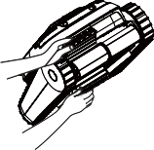 ES

7.2 Sustitución de las orugas
① Retire los paneles laterales: Retire las dos cubiertas de los tornillos. Con un destornillador Phillips, desatornille los dos tornillos que sujetan los paneles laterales y los paneles de las orugas. Retire los paneles laterales y los paneles de las orugas y déjelos a un lado.
② Limpie: Limpie el interior de los paneles laterales y séquelos con una toalla de papel o un paño.
③ Sustituya: Sustituya las orugas según sea necesario.

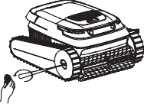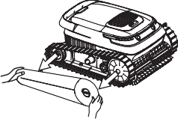

- La batería debe cargarse al menos cada 3 meses para evitar una sobredescarga.
- No deje el robot al alcance de niños o personas con capacidades físicas, sensoriales o mentales reducidas ni con falta de experiencia y conocimientos, a menos que hayan recibido supervisión o instrucciones.

Sustitución de piezas

Sustitución de los cepillos de los rodillos
① En la parte posterior de la correa de los cepillos de los rodillos, despegue las hebillas
Retire la cubierta de los tornillos y
desatorníllelos.

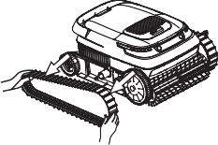
Retire los paneles laterales
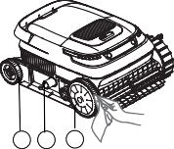

3 2 1

de silicona que fijan las ranuras de montaje. Retire las orugas. Reinigen Sie die Inenseite der Seinteile

Preguntas frecuentes
Si el problema persiste después de aplicar las soluciones sugeridas, póngase en contacto con el servicio de atención al cliente.
Problemas | Causas posibles | Soluciones
El robot no se carga. | - La toma no tiene corriente. | - Compruebe si la toma de corriente  funciona.
El robot no se carga. | - El cable de alimentación no está conectado de forma correcta a la toma de corriente. | - Compruebe la conexión entre el cable de alimentación y la toma de corriente.
El robot no se carga. | - La conexión entre el adaptador de corriente y el robot está suelta | - Compruebe la conexión entre el robot y el adaptador.
El robot no se carga. | - El adaptador de corriente no funciona. | - Compruebe si se muestra el LED de carga cuando el adaptador está conectado al robot. Si no es así, sustituya el cargador.
El robot no se carga. | - Ha entrado agua en el puerto de carga. | - Seque el puerto de carga e intente cargar de nuevo.
El robot no funciona o el indicador no se enciende. | - El robot no tiene batería suficiente. | - Utilice el robot después de cargarlo por completo.
El robot no funciona o el indicador no se enciende. | - El interruptor del robot falla. | - Intente apagar y volver a encender el robot.
El robot no trepa por las paredes. | - La batería está baja. | - Utilice el robot después de cargarlo por completo.
El robot no trepa por las paredes. | - Compruebe si el robot funciona en modo limpieza de suelos y limpia solo el suelo. | - Cambie al modo de limpieza de paredes.
El robot no trepa por las paredes. | - La cesta del filtro está obstruida. | - Limpie la cesta del filtro.

El robot no trepa por las paredes. | - Hay algas en la pared y el valor del pH no es correcto. | - Compruebe los niveles de productos químicos en el agua. Una mala calidad del agua puede permitir el crecimiento de algas, lo que hace que las paredes resbalen. En este caso, ajuste la calidad del agua y lave las paredes.
El robot no trepa por las paredes. | - Las orugas o los cepillos de los rodillos están desgastados. | - Sustituya las orugas o los cepillos de los rodillos.
El robot se mueve en círculos. | - La cesta del filtro está obstruida. | - Limpie la cesta del filtro.
El robot se mueve en círculos. | - Los residuos se atascan en las orugas o en los cepillos de los rodillos. | - Retire los residuos de las orugas o de los cepillos de los rodillos. Consulte la página 30 para ver las instrucciones de sustitución de piezas.
El robot se detiene bajo el agua y el indicador de fallos indica que el motor o la bomba de agua están bloqueados. | - Los residuos se atascan en las orugas o en los cepillos de los rodillos. | - Si el motor está atascado, compruebe si la oruga izquierda/ derecha puede girarse de forma manual. Si no es así, compruebe si hay obstrucciones en la oruga.
 | - Los residuos bloquean el impulsor del motor de la bomba de agua. | - Si el motor de la bomba de agua está atascado, compruebe si hay obstáculos en los impulsores.
Hay gotas de agua y suciedad en el robot recién comprado. | - Se ha sometido a todos los robots a rigurosas pruebas antes de salir de fábrica, entre ellas pruebas bajo el agua. Por lo tanto, puede haber una pequeña cantidad de gotas de agua o suciedad en el interior. No dude en utilizar el robot con normalidad.nz normal benutzt werden. | - Esto no afecta al funcionamiento del robot.

ES

Best Epoch Technology Co., LTD 2201, Block C1, Nanshan I Park, No. 1001 Xueyuan Road, Nanshan District, Shenzhen City, China P.R
©Best Epoch Technology Co., LTD. All Rights Reserved. The pictures of the product are for reference only and subject to change without notice.
MADE IN CHINA A30441

